**Fonts Used :**

1.For Buttons - Source Sans Pro <https://fonts.google.com/specimen/Source+Sans+Pro> 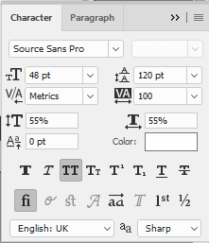

2.For Simple Text - (Greek) Open Sans

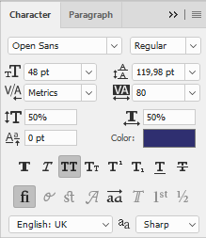

**Color Palette Used :**

Dark Primary Color : #1e2133 (Background Dark Blue - Also used for text)

Dark Secondary Color : #2f334b (Background Lighter Blue - for Highlighted Sections)

Light Primary Color : #fff (Background White - for User Area)

Light Secondary Color : #cbcaca (Footer Grey - Also used for text)

Accent Color : #299858 (Green - for Buttons)

**Icons Used:**

Link Icon : <https://fontawesome.com/icons/link?style=light>

Avatar Icon : <https://www.flaticon.com/packs/avatar-set>

Scroll Arrows Icon : [https://www.flaticon.com/free-icon/scroll-arrows](https://www.flaticon.com/free-icon/scroll-arrows_3679#term=scroll&page=1&position=23)

Export Icon : [https://www.flaticon.com/free-icon/export](https://www.flaticon.com/free-icon/export_243717#term=export&page=1&position=28)

Plus Icon : [https://www.flaticon.com/free-icon/add](https://www.flaticon.com/free-icon/add_148775#term=plus&page=1&position=13)

Png Icon : [https://www.flaticon.com/free-icon/png](https://www.flaticon.com/free-icon/png_136523#term=png&page=1&position=1)

Pdf Icon : [https://www.flaticon.com/free-icon/pdf](https://www.flaticon.com/free-icon/pdf_337946#term=pdf&page=1&position=2)

Jpg Icon : [https://www.flaticon.com/free-icon/jpg](https://www.flaticon.com/free-icon/jpg_136524#term=jpg&page=1&position=1)

Info Icon : [https://www.flaticon.com/free-icon/info](https://www.flaticon.com/free-icon/info_131917#term=info&page=1&position=6)